Python - Windows
- Download the installer first:
Go to the official website: python.org/downloads
Download the latest stable version like 3.12 etc.
https://www.python.org/downloads/windows/
- Click on the version you want to install.

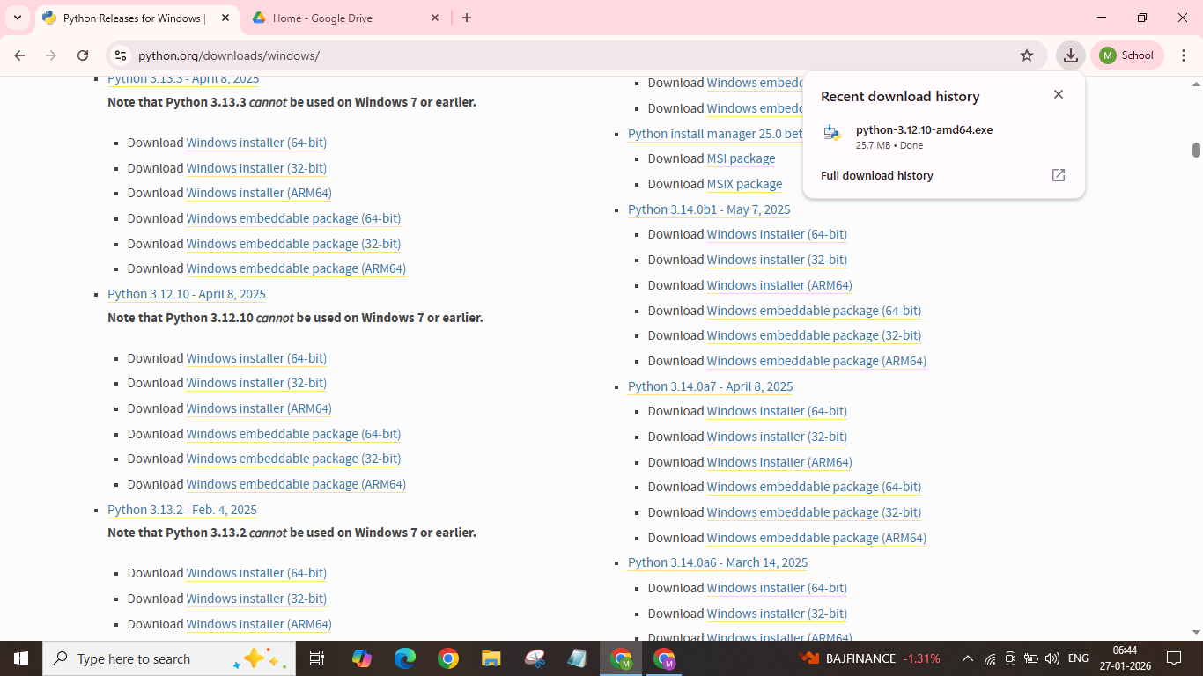

- Once downloaded click on it for the next process.
- If you are installing for the first time.
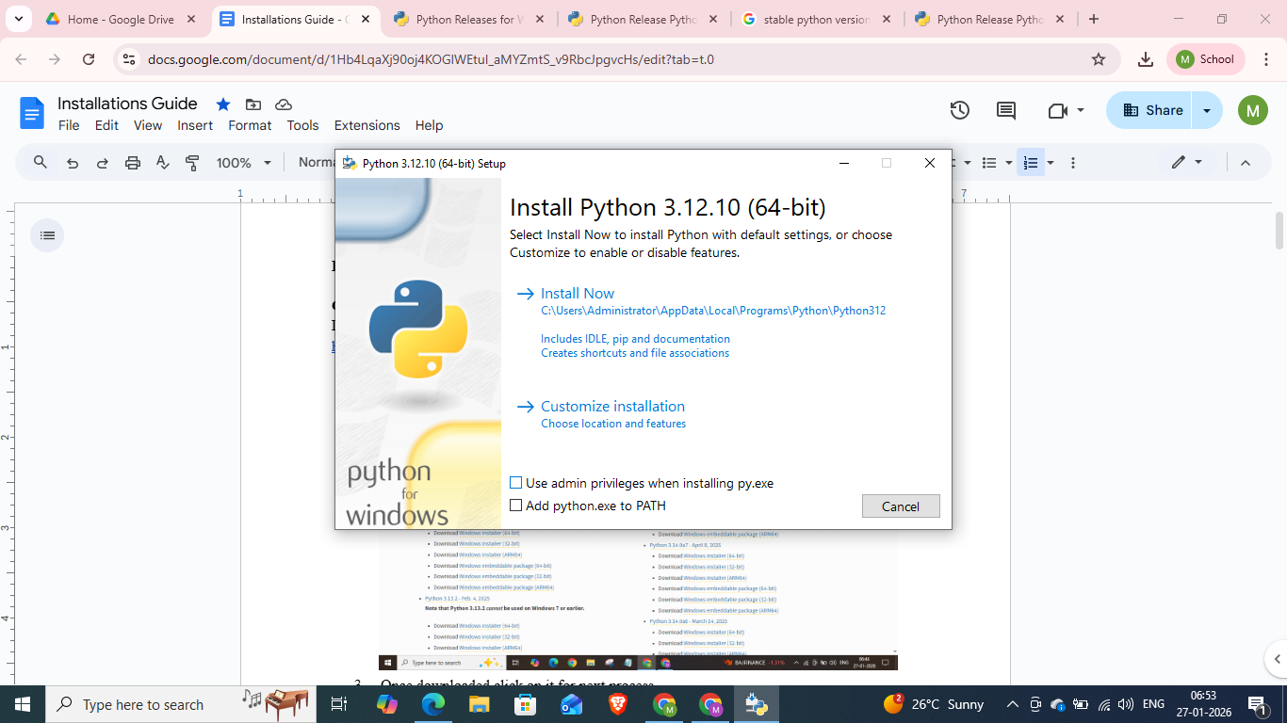
- If you already have python installed but wanted to upgrade.
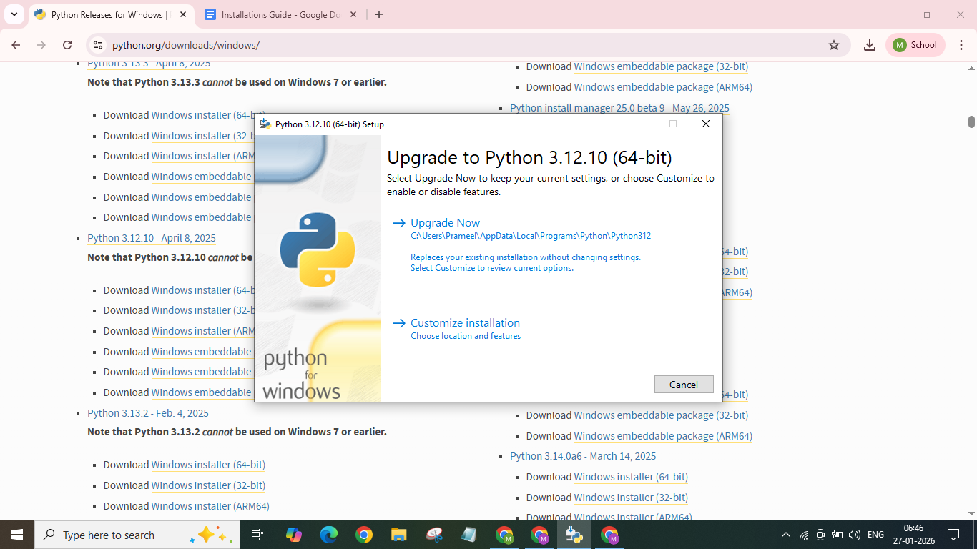
Once done , click on the downloaded folder again,
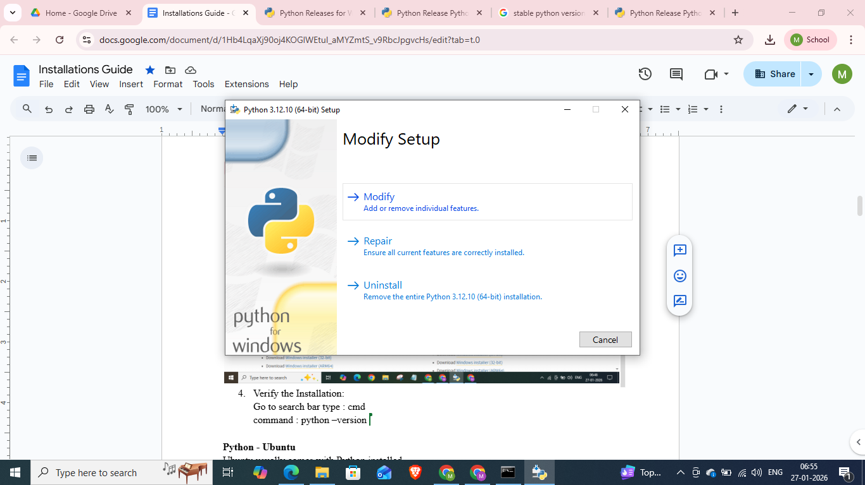
Click on modify and select the needed steps for later use also.
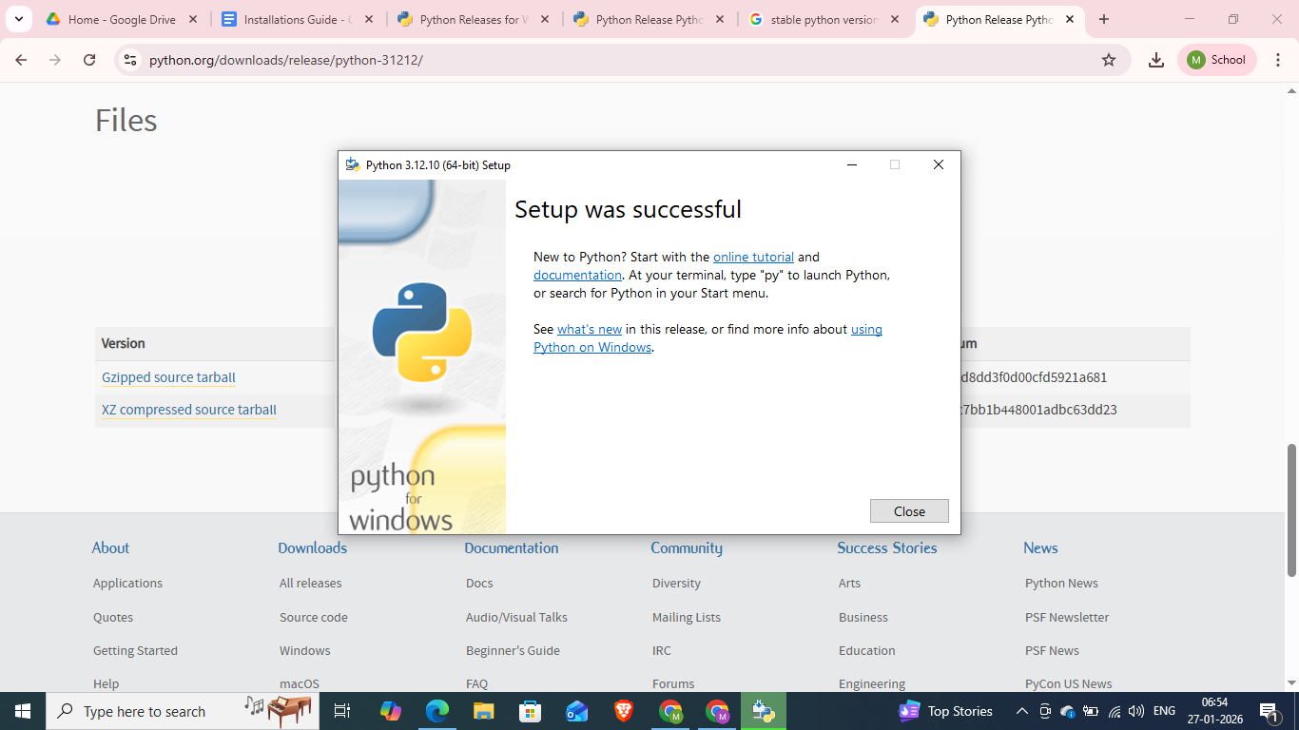
- Verify the Installation:
Go to search bar type : cmd
command : python –version
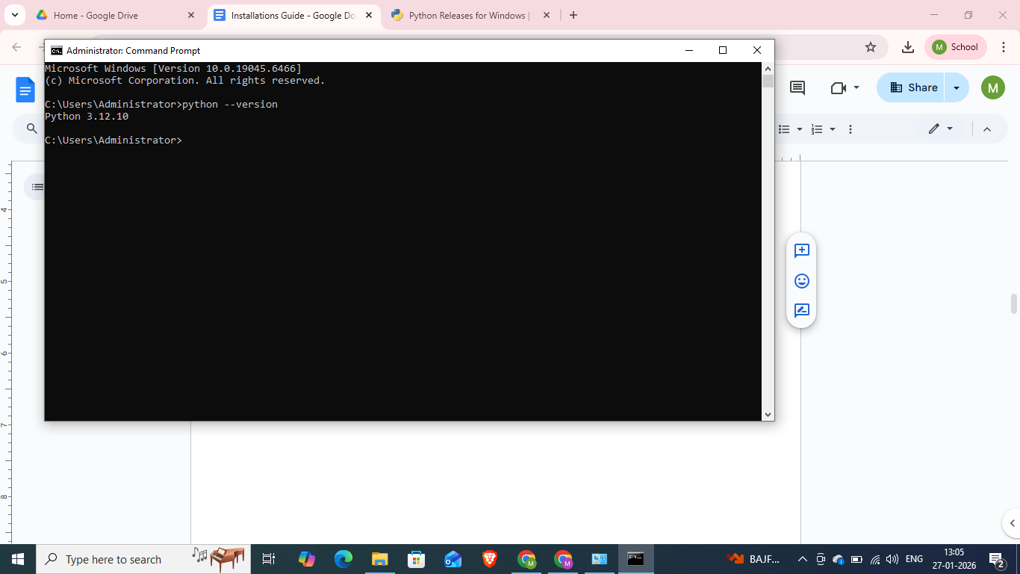

Python - Ubuntu
Ubuntu usually comes with Python installed.
Run these commands to ensure you have the full setup including pip and venv:

- command: sudo apt update
- Command: sudo apt install python3 python3-pip python3-venv -y
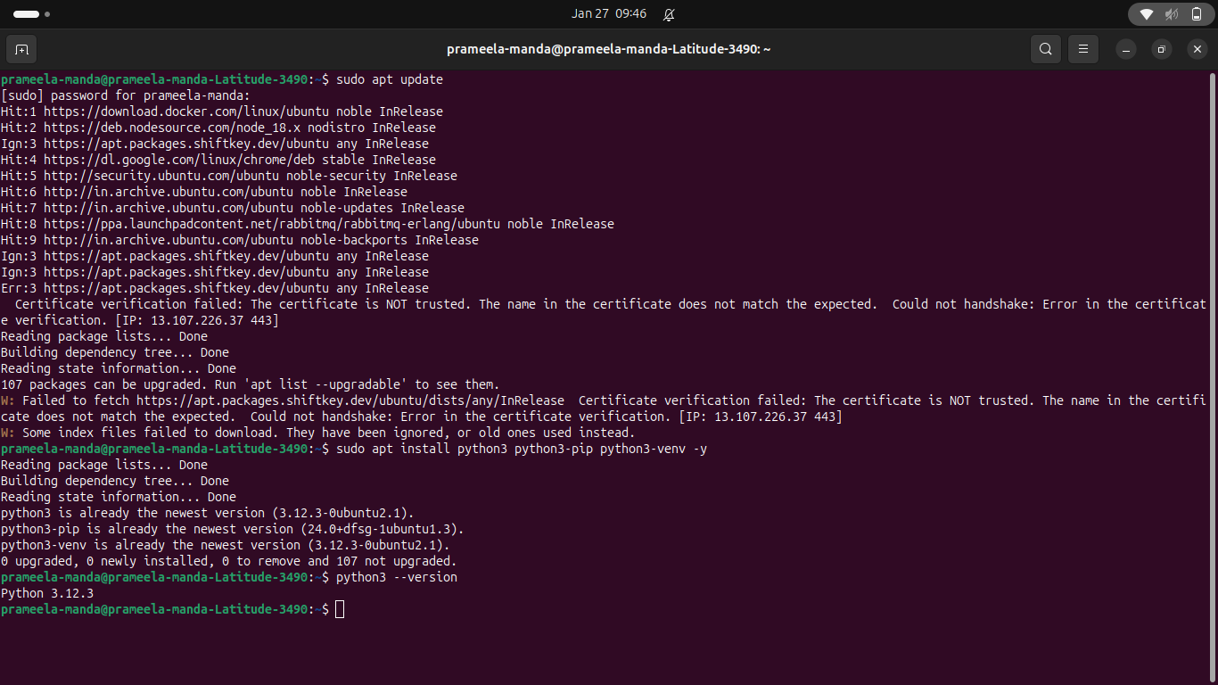

Check once installed.
- python – version
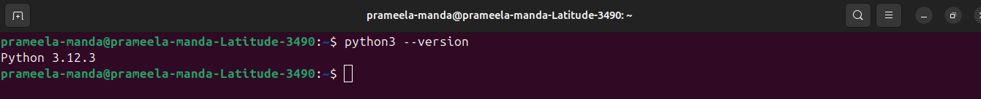

Visual Studio Windows:
- Download the Installer
a. Go to the official site: code.visualstudio.com
Click on download -> select windows
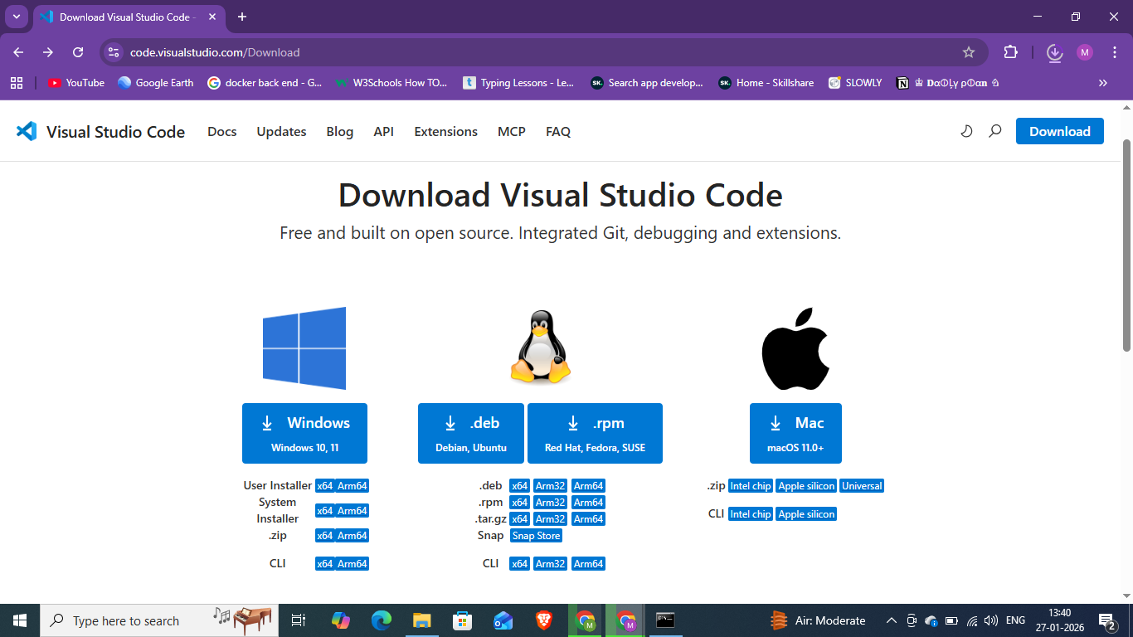

- Once installed click on next and select create a desktop icon, so it can be accessed easily.
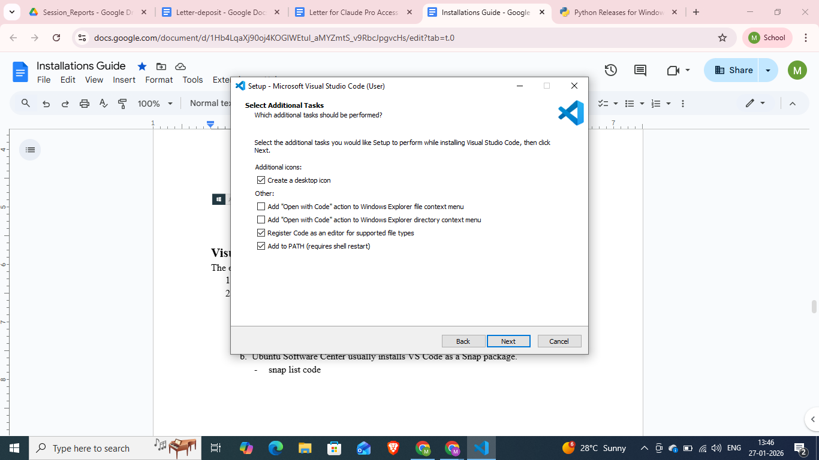

- This is the final Screen, click on Finish it opens the Visual Studio.
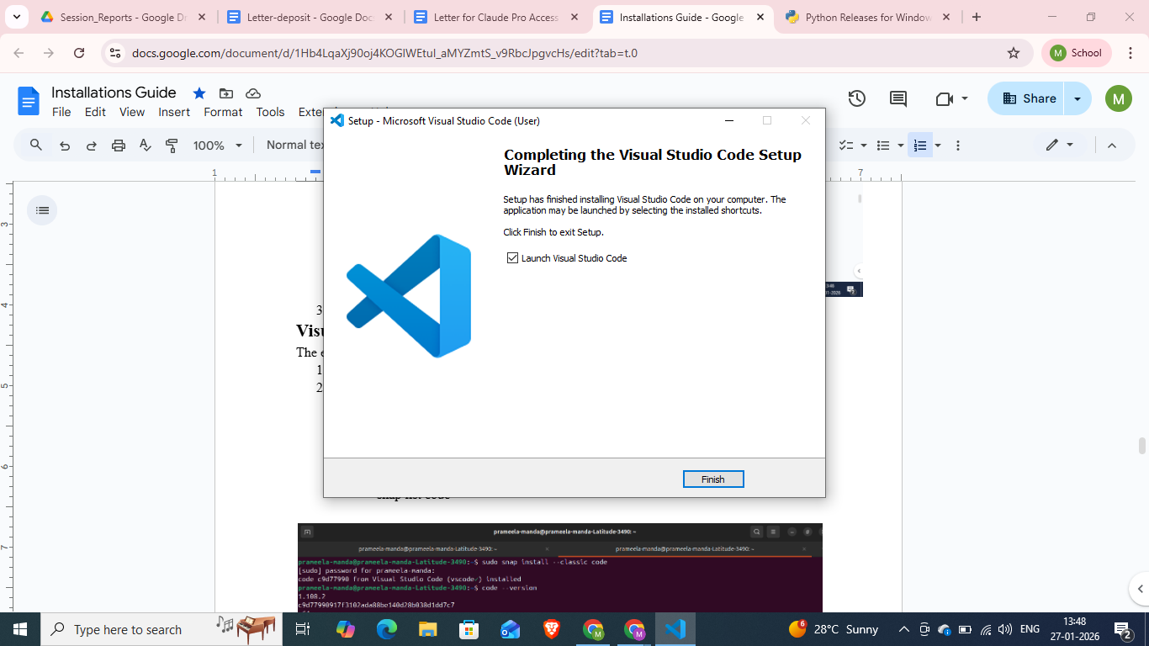

For Virtual Environment :
- Create a folder on your desktop.
- Open in visual studio and go to terminal
- command: python -m venv .venv #creates the environment
- If there is any error occurrence use the following command :
Set-ExecutionPolicy Unrestricted -Scope Process
- command : .\.venv\Scripts\activate # activates the environment
- 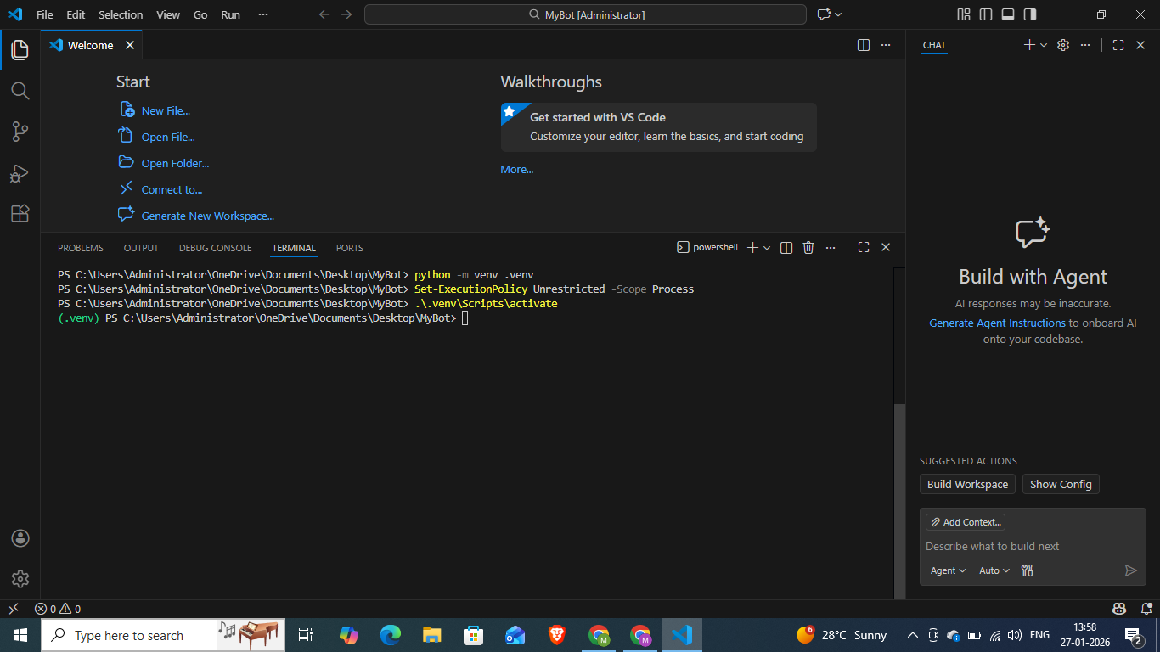
- Our virtual environment is ready.

Selenium Installation Windows:
- command: pip install selenium
- If required update pip by using command: python.exe -m pip install --upgrade pip
- Copy paste the below code in .py file and run the code.

from selenium import webdriver
import time
print("Starting the browser...")
# 1. This initializes the Chrome browser
# Selenium Manager (built-in) will automatically download the correct driver
driver = webdriver.Chrome()
# 2. Go to a website
driver.get("https://www.google.com")
# 3. Print the title of the page to the terminal
print("Page Title is: " + driver.title)
# 4. Wait for 5 seconds so you can see the browser open
time.sleep(5)

# 5. Close the browser
driver.quit()
print("Browser closed. Test successful!")

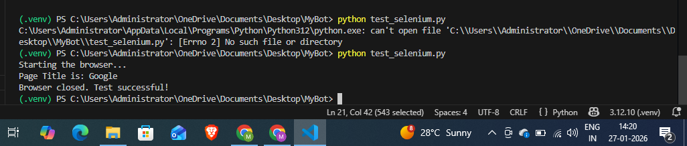

Visual Studio Ubuntu:
The easiest way is via the Snap Store (pre-installed on Ubuntu):
- command: sudo snap install --classic code
- a. The quickest check whether we have installed it or not is
- Manual checking in app store
- code – version
If installed, you will see numbers like 1.96.0 followed by a hash ID. If not found, it will say command not found.
b. Ubuntu Software Center usually installs VS Code as a Snap package.
- snap list code

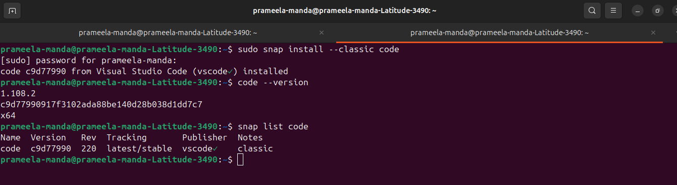
- To open Visual Studio from terminal type code .
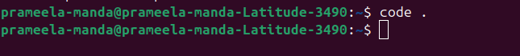

Selenium Installation Ubuntu:
- Create a folder and open it.
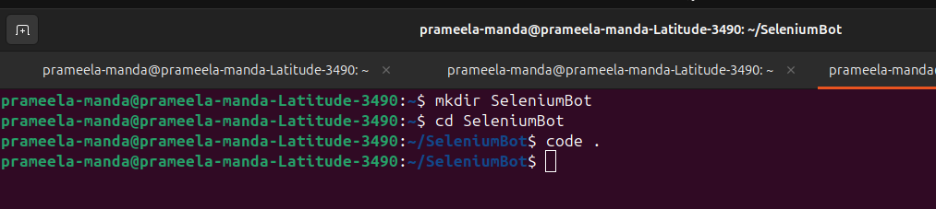

- Open the integrated terminal press Ctrl + `
- command : python3 -m venv .venv # creates a virtual environment.
- command: source .venv/bin/activate # Activate the environment
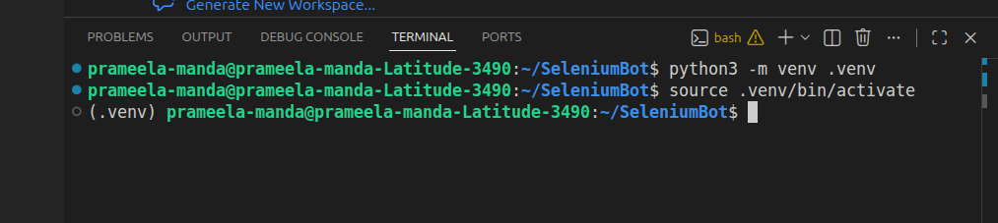
- pip install selenium
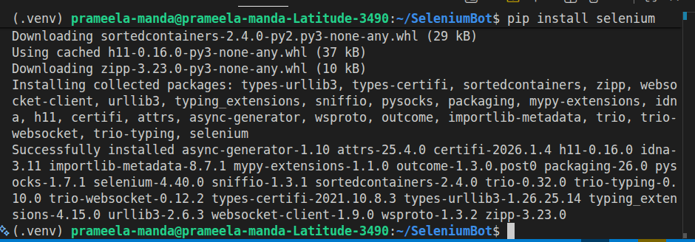
- Testing our Setup
- Create a new file named test_bot.py in your VS Code folder.
- Paste the following code to test if Chrome launches:

from selenium import webdriver
import time

# Initialize the driver (Selenium Manager handles the executable)
driver = webdriver.Chrome()

# Open a website
driver.get("https://www.google.com")

print("Page title is:", driver.title)

# Keep browser open for 5 seconds
time.sleep(5)

# Close the browser
driver.quit()

- Run the script by clicking the Play button in the top right, or typing python test_bot.py in the terminal.
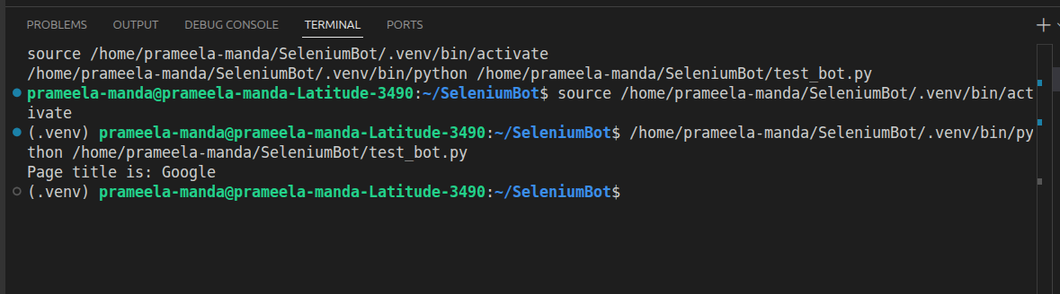

Github - Copilot Installation Windows/Ubuntu:
To install GitHub Copilot on Ubuntu, you actually install it as an extension inside Visual Studio Code. You don't need to install a separate application for the OS itself.
- We need VS code in our system.
- A GitHub account with an active Copilot subscription or free trial.
- Open VS Code and click Ctrl + Shift + x # this opens the Extensions.
- Type Github Copilot in extensions and install the first two extensions.
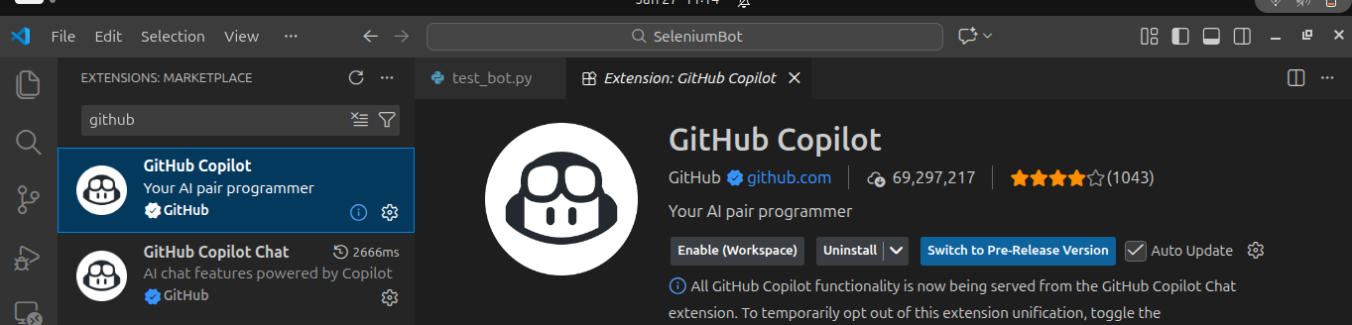
- Once done, you can see the github Copilot chat.
- Sign In: Once installed, a popup will appear in the bottom right asking you to sign in to GitHub.
- Click Sign in to GitHub.
- Your browser will open. Authorize VS Code to access your GitHub account.

